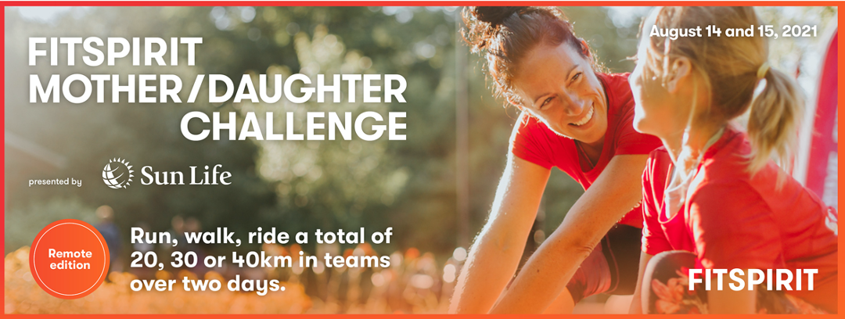

Dear [name of person you are soliciting],

On August 14th and 15th, my [mother/daughter] and I will participate in the FitSpirit Mother/Daughter Challenge. We will complete a [20 km/30 km/40 km] [run/walk/bike ride] in teams over the course of two days where the proceeds go to FitSpirit, an organization that encourages teenage girls to get active and stay active for life.

One girl out of two quits sports at puberty and the trend increases dramatically between ages 12 and 17, where 9 girls out of 10 fail to meet Canada’s daily exercise guidelines by the end of high school. My [mother/daughter] and I are participating in the FitSpirit Mother/Daughter Challenge in order to help reverse the trend, and we need your support.

It’s easy to contribute. Just go to our personal fundraising page and give what you can: [insert link to your personal fundraising page]. Any amount you donate to support our participation in the Mother/Daughter Challenge will make a difference in the lives of teenage girls.

Thank you in advance for your generosity.

[Your name]

